Name:  Class: | ____________________________________  ________________ | Date:_________
 | Year 8 Mathematics 2019  /45  Test 4  Resources Allowed: calculator/ page of notes / ruler  Time allowed: 55 minutes  Full working out MUST be shown to get full marks for each question.

SECTION ONE: MULTIPLE CHOICE (circle the correct answer) [5 marks]

- What is the value of $p$ in $p-4= -3$
- $-7$
- $7$
- $-1$
- $1$

- What is another name for slope
- Intercept
- Gradient
- Axis
- Line

- For the linear equation $y=-x+5$. If $x$ is $3$ what is $y$
- $8$
- $-8$
- $2$
- $-2$
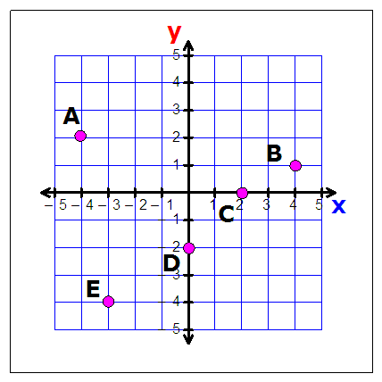
- Using the graph, which point has a $y$ value of 0
- A
- B
- C
- D

- using the graph, which point has a $x$ value of 0
- B
- C
- D
- E

SECTION TWO: SHORT ANSWER QUESTIONS (show working out if necessary) [40 marks]

- Look at the Cartesian plane below and write down the coordinates of the points A, B and C
[5 marks]

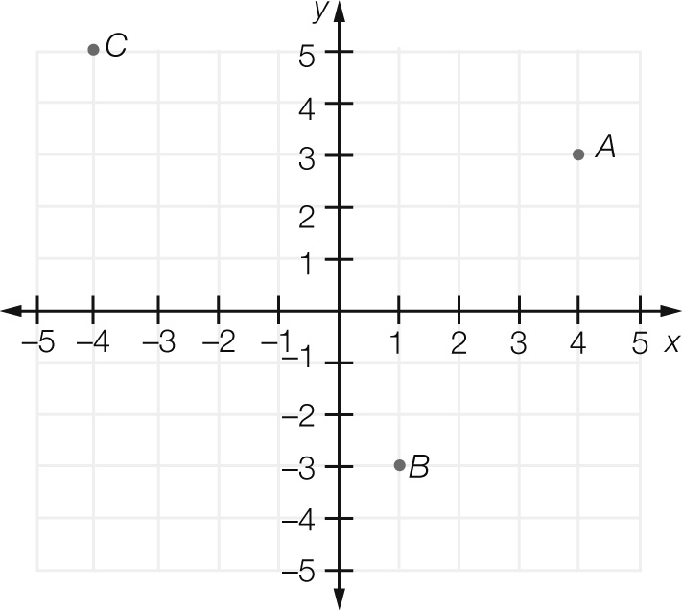
A ______________

B ______________

C ______________

Using the same Cartesian plane above place a on the coordinates $(-3, -2)$ and $(0, 4)$

- Circle which of the following coordinates lie on the line $y=10-3x$. Use mathematical reasoning to explain your choice. [2 marks]
- $(1, 3)$
- $(3, 1)$

- Use the rule $y = 4x + 2$ to fill in the table below then plot as a linear graph [6 marks]

x | -3 | -2 | -1 | 0 | 1 | 2 | 3
y

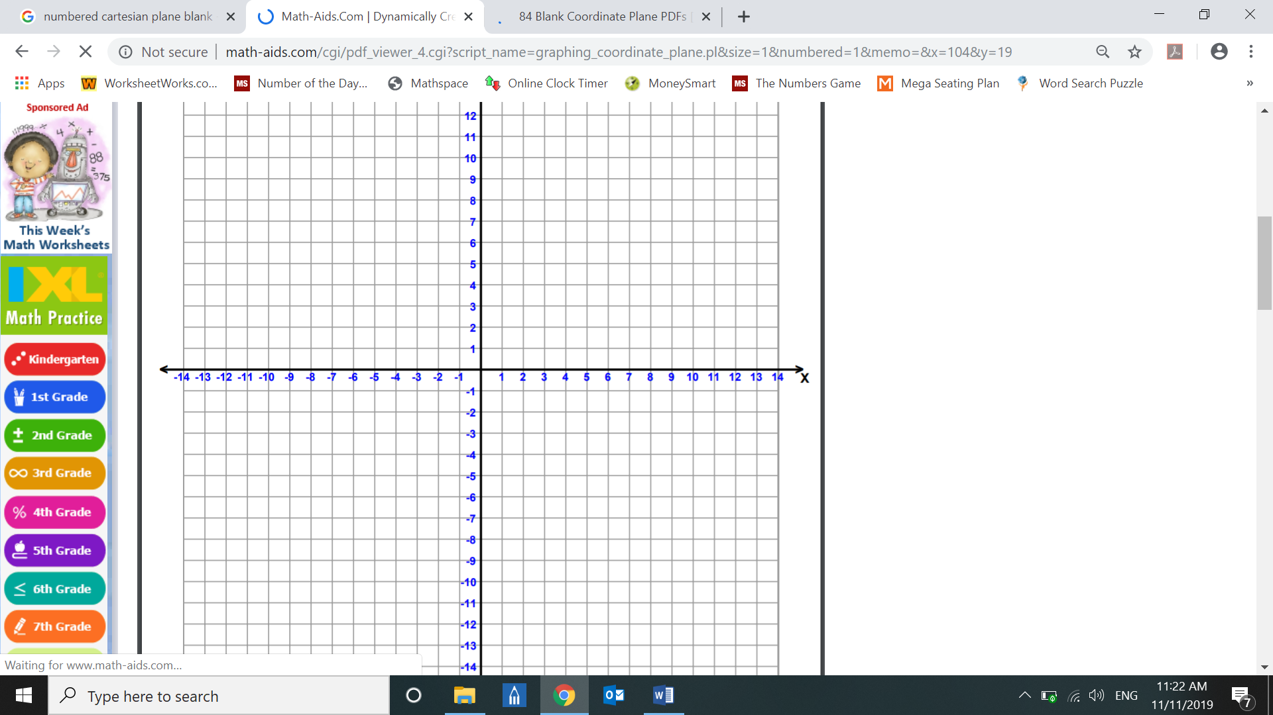

- Find the rule for these tables of values. [2 marks]

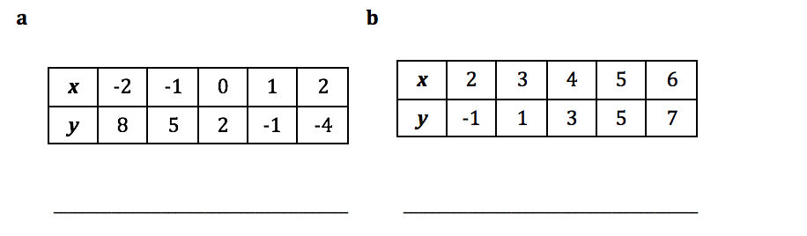

- Find the equation of this line (complete a table of values to help you!) [4 marks]

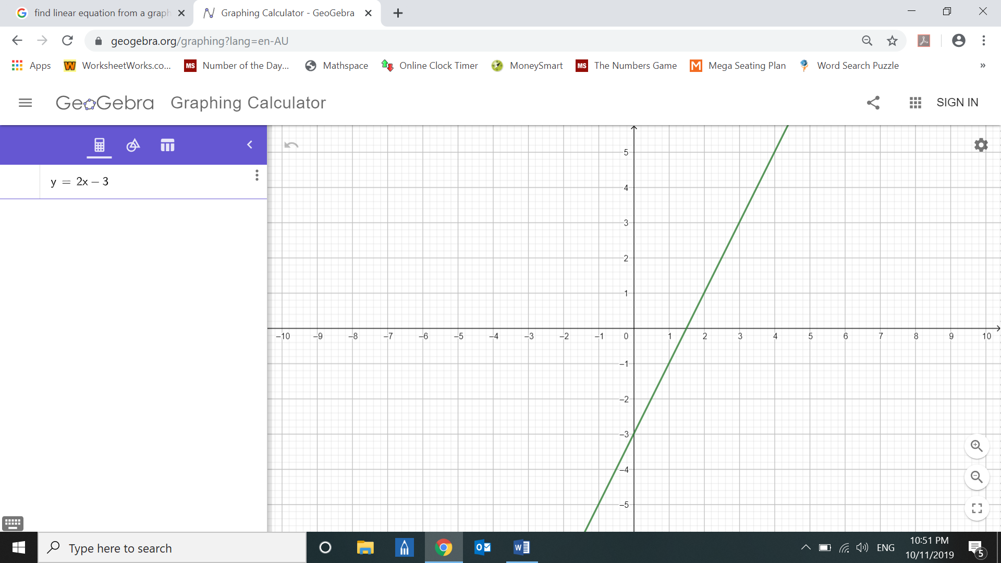

- In a class of 29 students, 13 have black hair, 10 have brown eyes and 5 have both black hair and brown eyes. Complete the Venn diagram representing this information. [6 marks]

5

- How many students do not have black hair?

- How many students do not have brown eyes?

- How many students have black hair or brown eyes?
- A sample of teenagers between the ages of 16-19 were asked whether they passed or failed their driving test the first time. The results were further categorised by gender as shown [10 marks]

 | Boys | Girls | Total
Passed | 7 |  | 23
Failed | 5
Total |  | 20

- Complete the above two-way table
- How many teenagers participated in the survey?

- How many of the teenagers surveyed failed their driving test?

- Find the probability that a randomly selected student:
- Is a girl who passed the test

- Did not pass their driving test

e. What percentage of girls passed the test?

- In a group of 19 people waiting at the bus stop one morning, 13 people had an umbrella, 4 people had a raincoat and 5 had neither an umbrella or a raincoat. Draw a Venn diagram or a two-way table to represent this information. [5 marks]

What is the probability that a randomly selected person:
- Has a raincoat but not an umbrella?

- Has an umbrella or a raincoat but not both?

END OF TEST

